📄 PROJECT DOCUMENT: ADF + Databricks End-to-End Pipeline
End-to-End Data Pipeline using Azure Data Factory and Databricks with Logging Framework

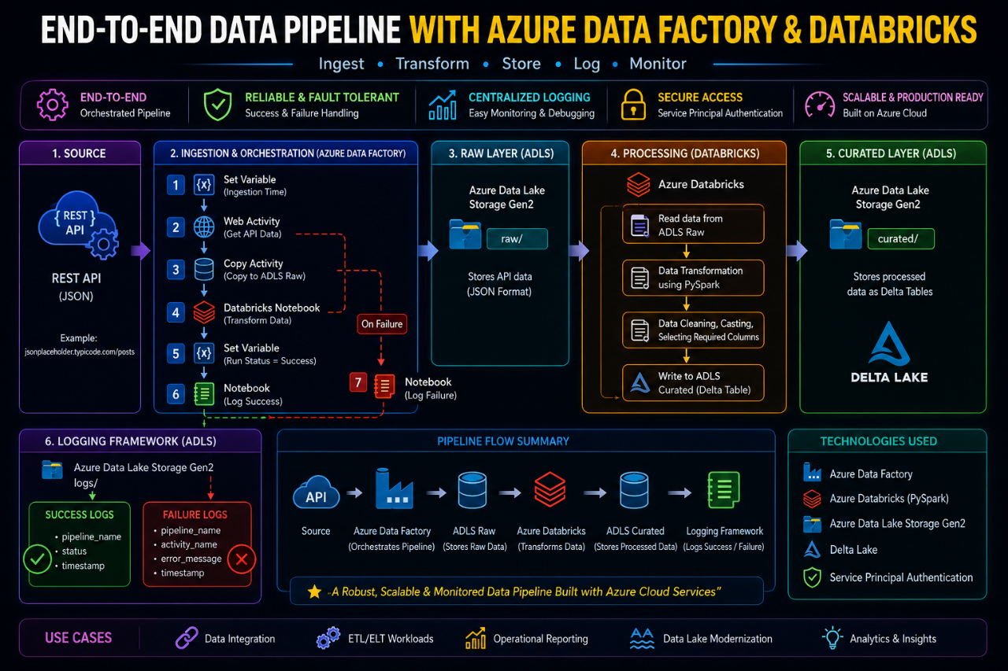
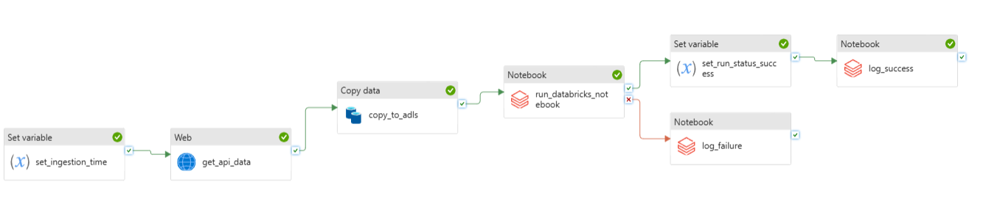
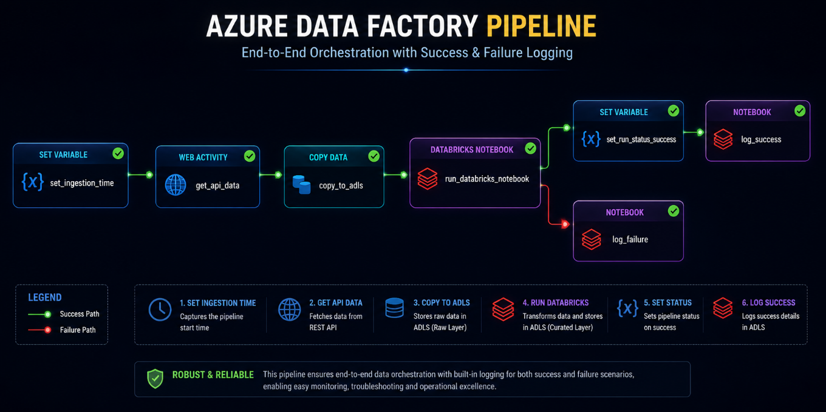

🎯 Objective
To design and implement a scalable data pipeline that:
- Ingests data from an API
- Stores raw data in ADLS (Data Lake)
- Transforms data using Databricks (PySpark)
- Loads processed data into curated layer
- Implements success and failure logging mechanism

🧰 Tools & Technologies
- Azure Data Factory (ADF)
- Azure Data Lake Storage Gen2 (ADLS)
- Azure Databricks (PySpark)
- Delta Lake
- Service Principal (Authentication)
📦Data Source
- Public API:
https://jsonplaceholder.typicode.com/posts

🗂 Data Layers
Layer | Description
Raw | Stores API data as-is
Curated | Stores transformed Delta tables
Logs | Stores success and failure logs
🔄 Pipeline Workflow
1. Set ingestion time
2. Fetch data from API
3. Store data in ADLS (raw layer)
4. Transform data using Databricks
5. Store processed data in curated layer
6. Log success or failure

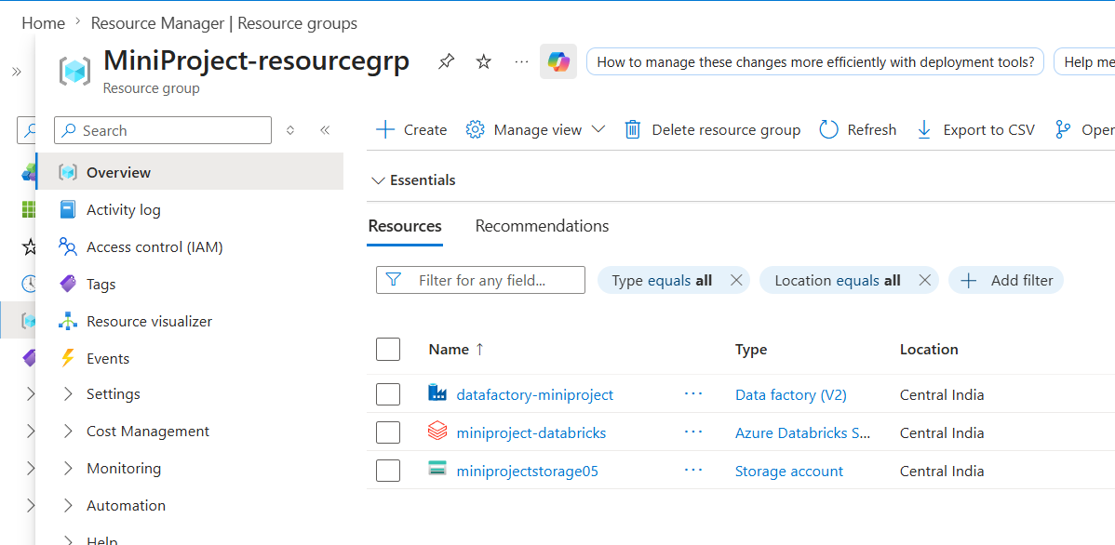

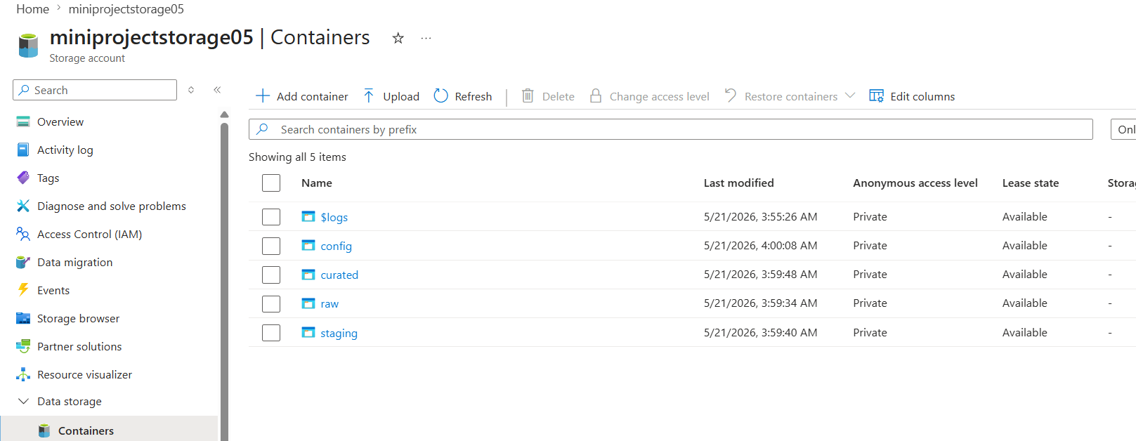

Built the Json file and uploaded it in config container as shown below:-
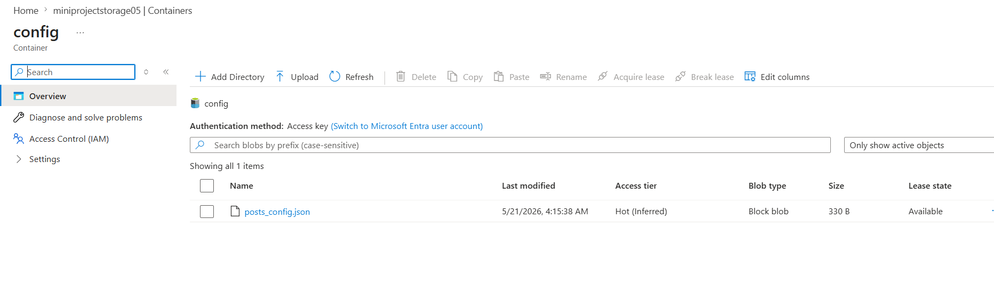
Created two datasets for source and sink as shown below:-

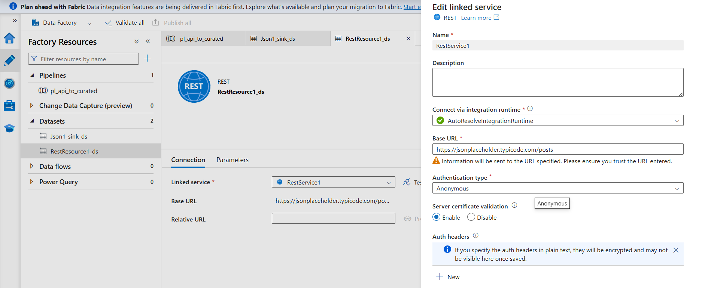
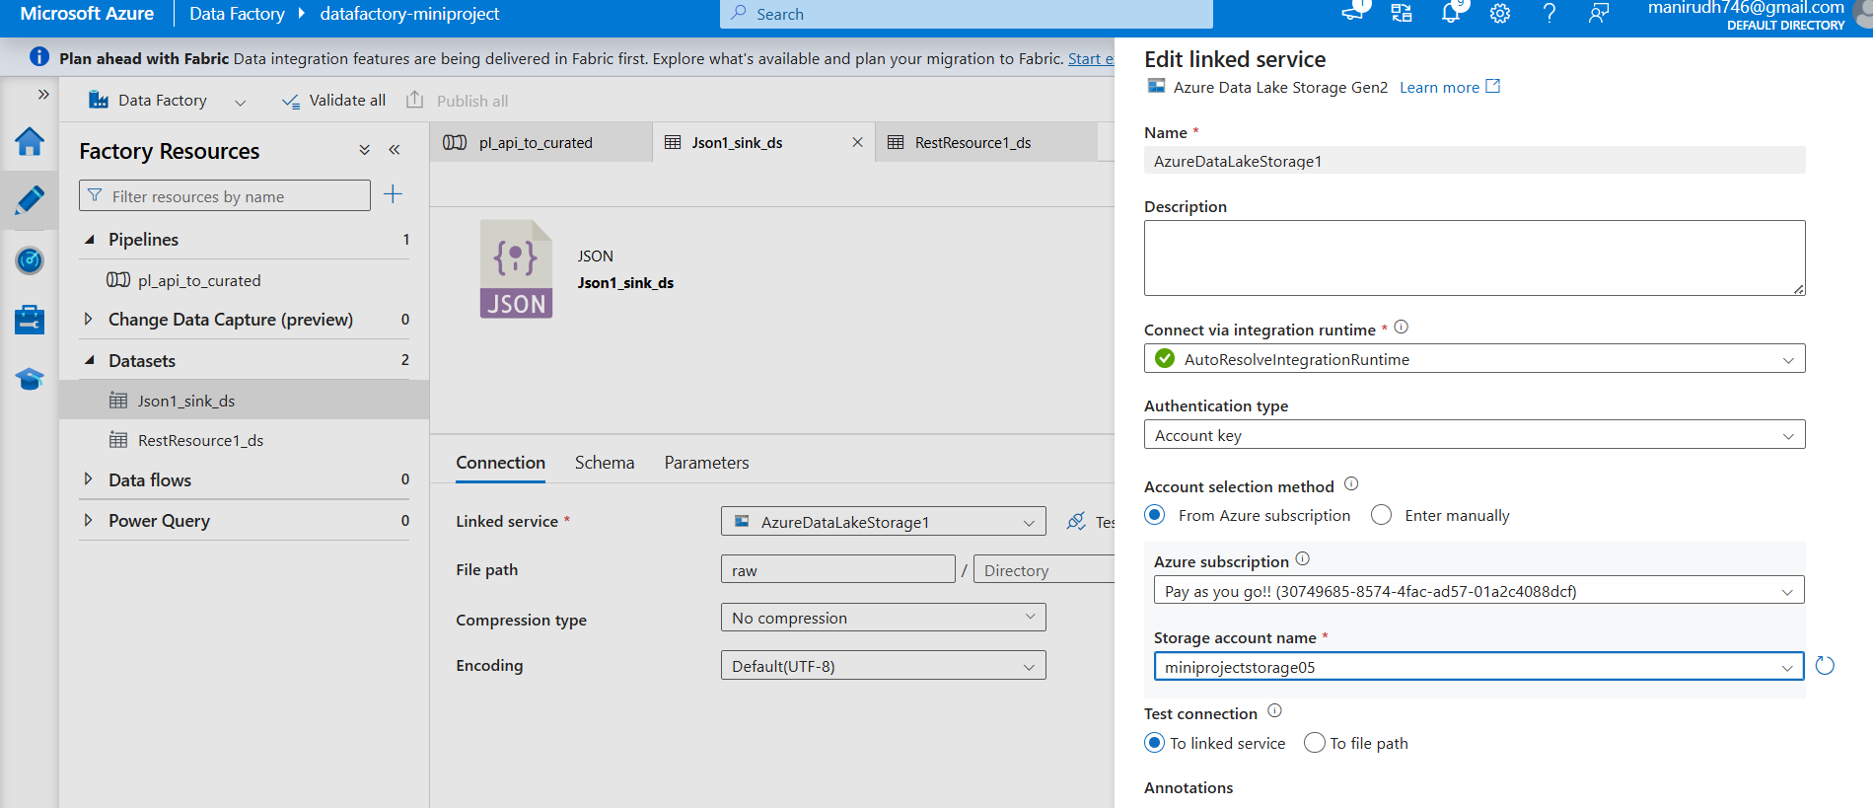

⚙️ ADF Pipeline Activities

🔹 1. Set Variable
- Stores ingestion timestamp
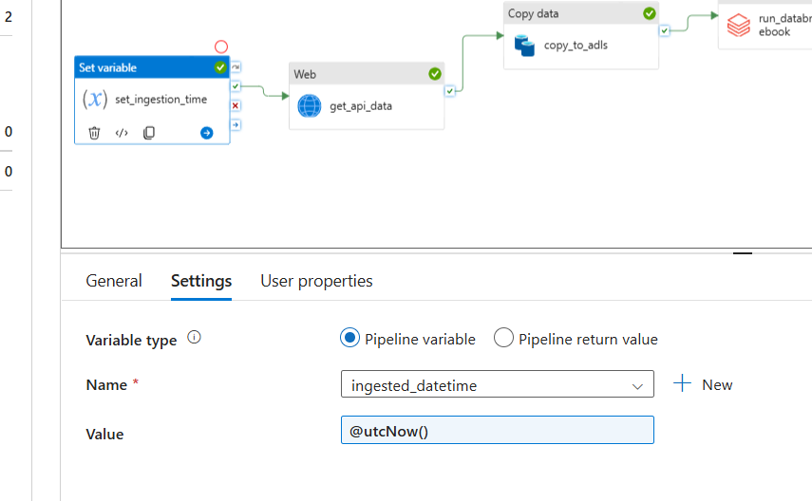

🔹 2. Web Activity (get_api_data)
- Calls API and retrieves data
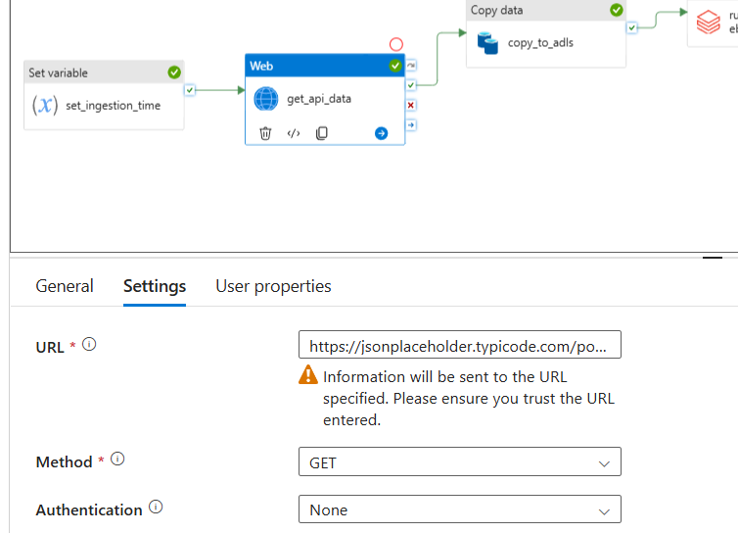

🔹 3. Copy Activity (copy_to_adls)
- Copies API data to ADLS raw layer
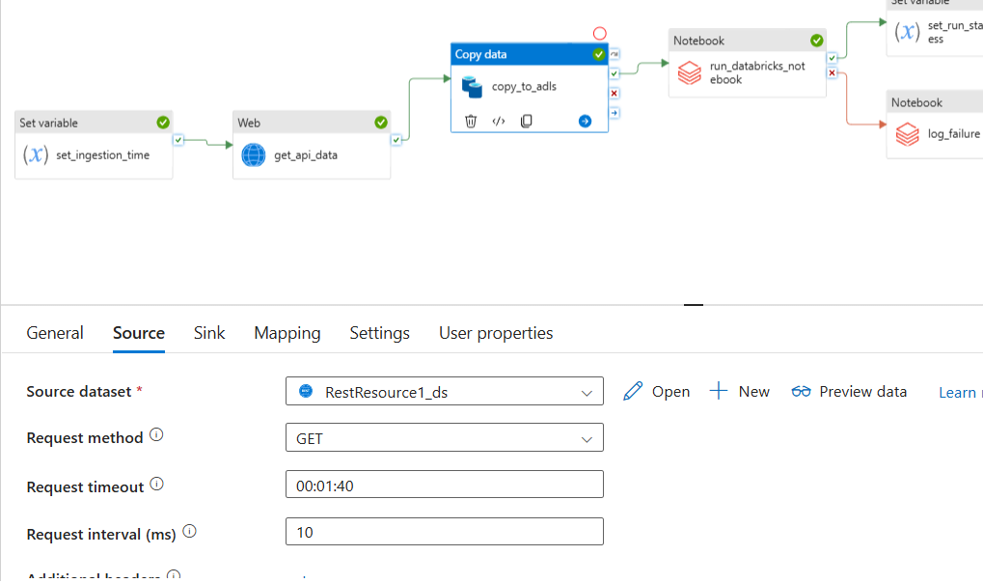
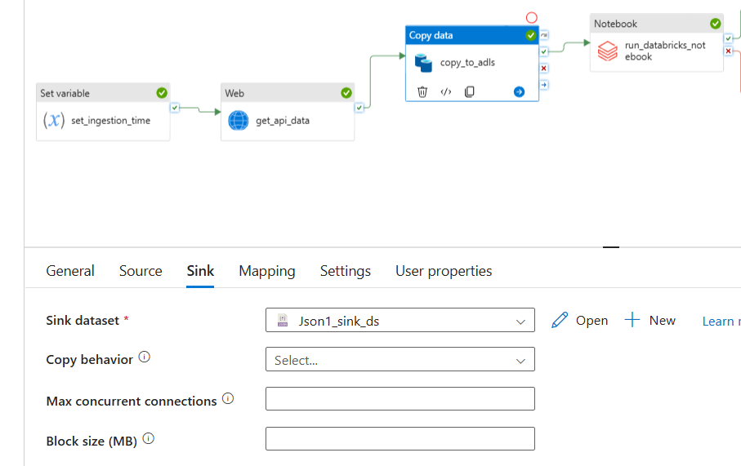

🔹 4. Databricks Notebook (run_databricks_notebook)
- Reads raw data
- Applies transformations
- Writes to curated Delta table
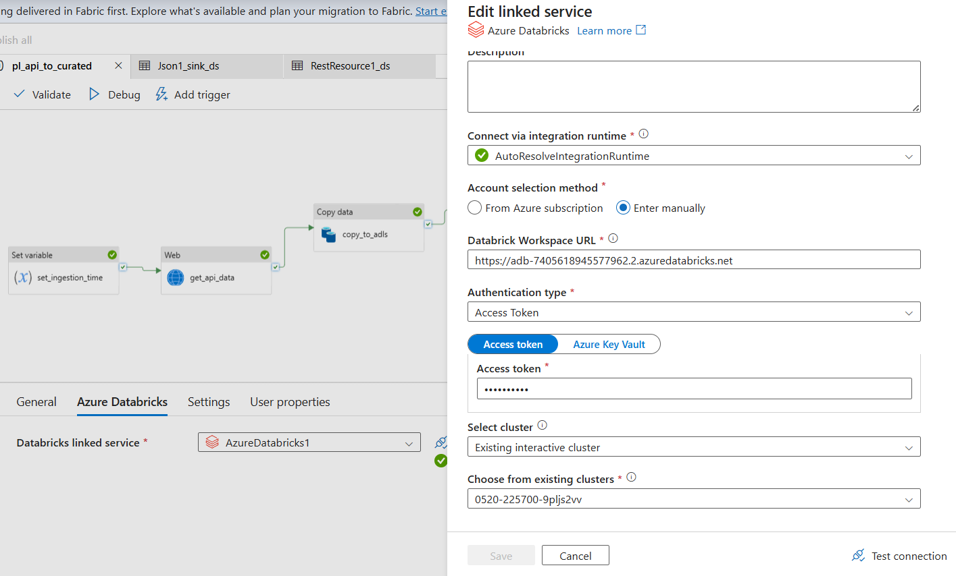
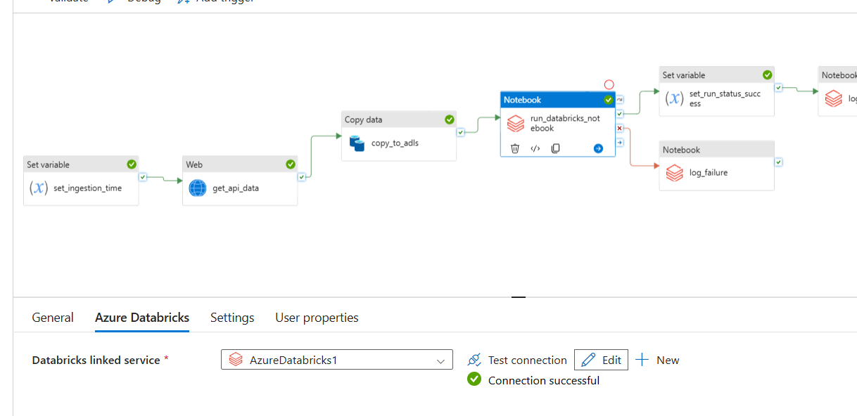
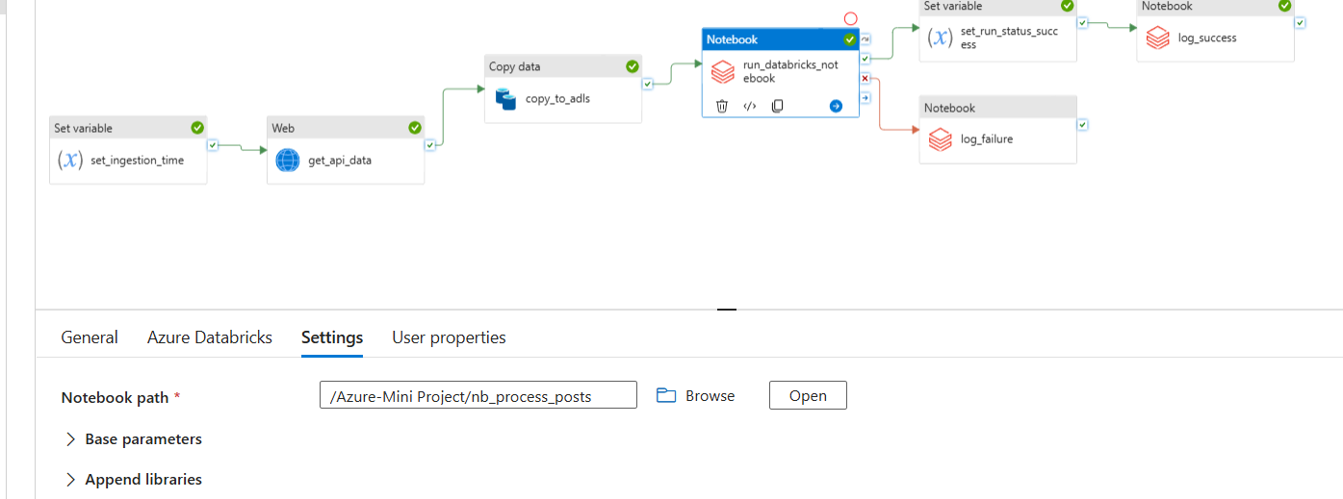

🔹 5. Set Variable (set_run_status_success)
- Marks pipeline as SUCCESS
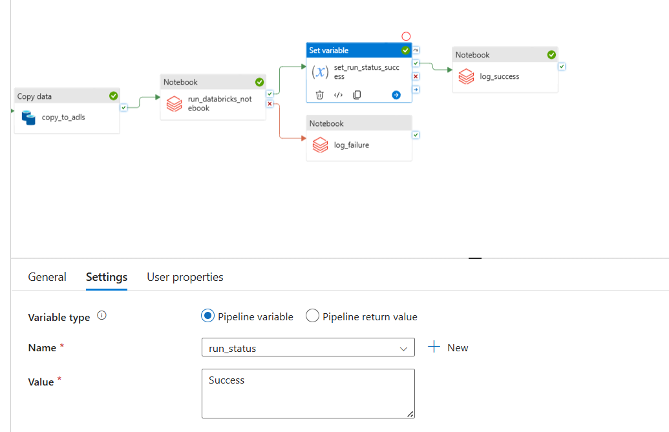

🔹 6. Notebook (log_success)
- Logs successful execution
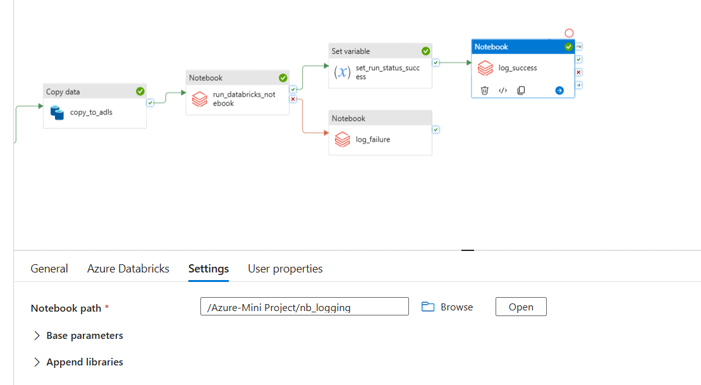

🔹 7. Notebook (log_failure)
- Logs failure details (triggered on failure)
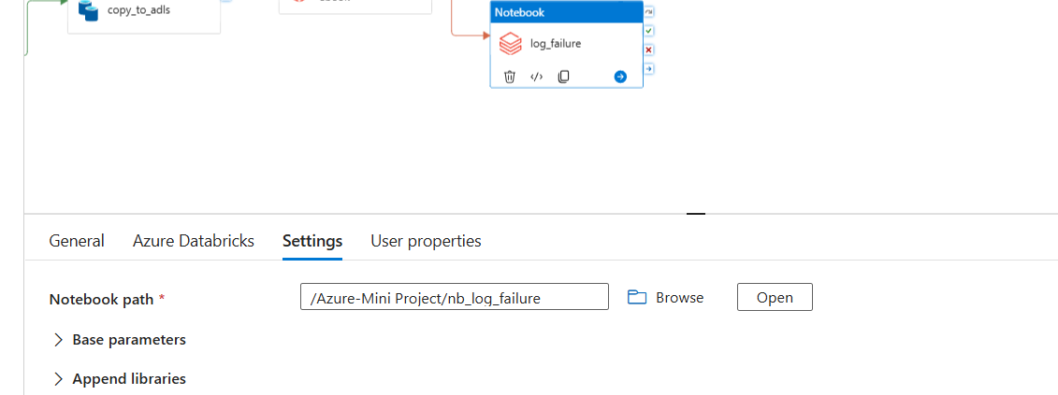

🔀 Pipeline Flow Logic
run_databricks_notebook
├── Success → log_success
└── Failure → log_failure

🔐 ADLS Connection (Service Principal)
Used OAuth authentication:
- Client ID
- Client Secret
- Tenant ID
Access via:
abfss://<container>@<storage-account>.dfs.core.windows.net/
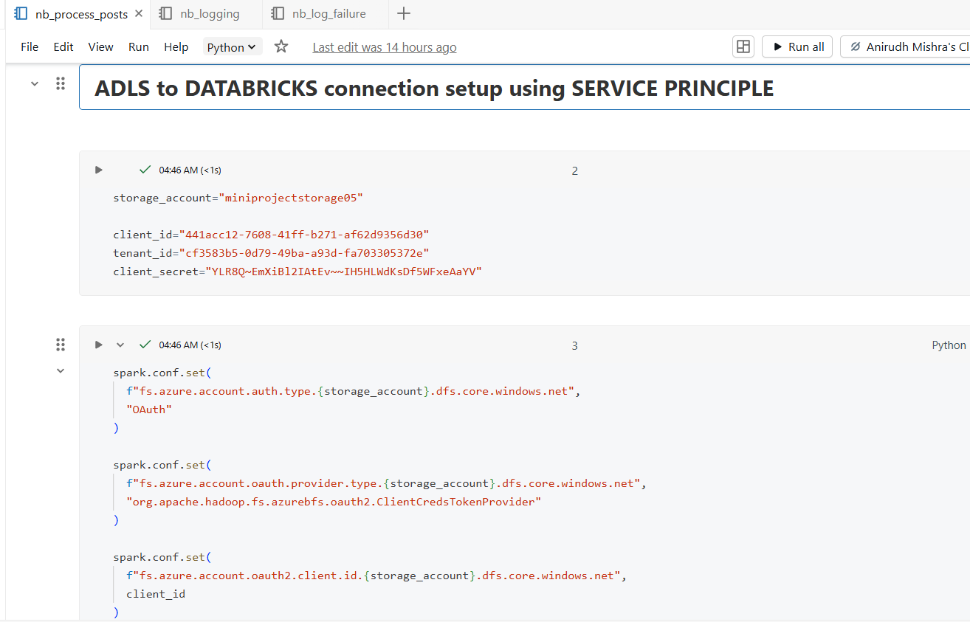
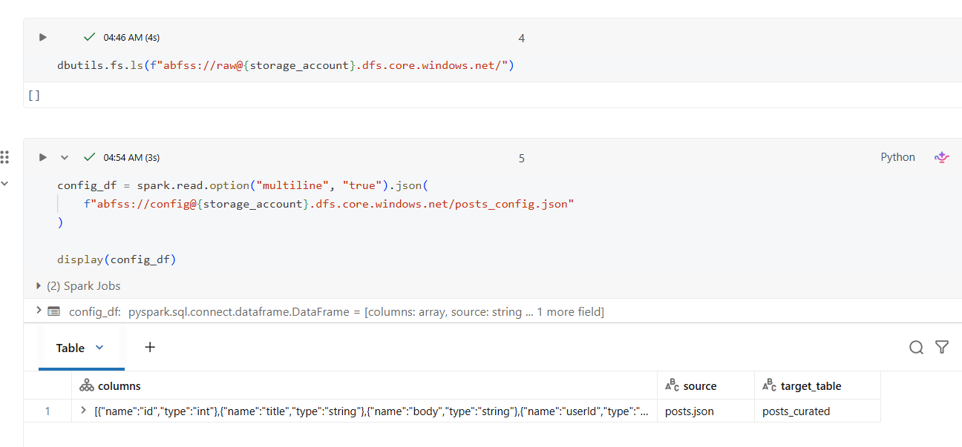
🧠 Databricks Processing Logic
Steps:
- Read raw JSON data
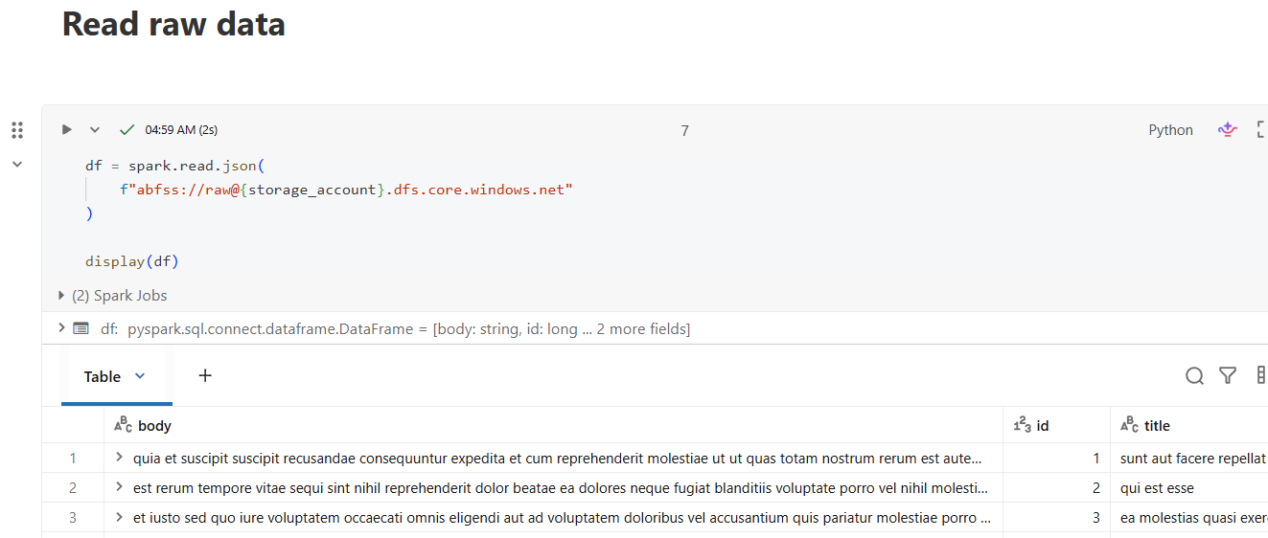
- Perform schema casting
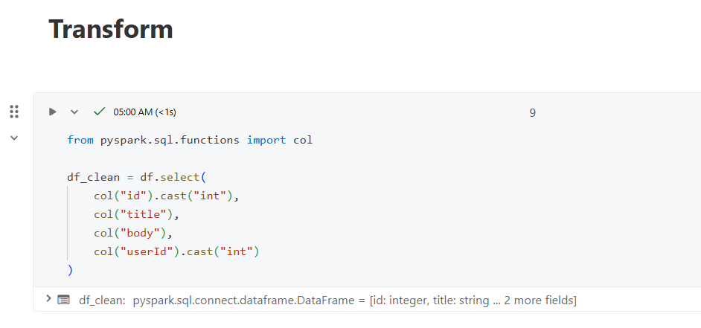
- Select required columns
- Write to Delta table
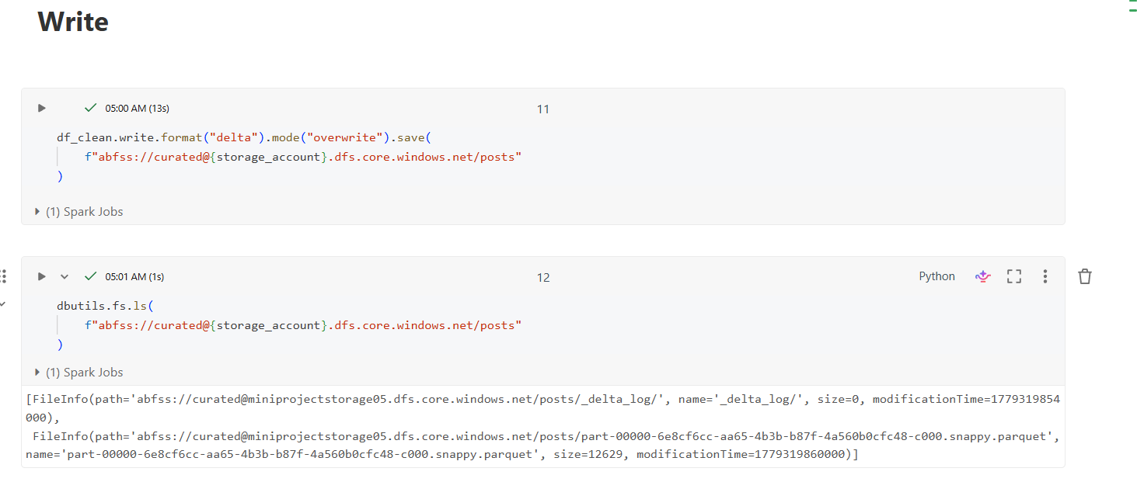

📊 Logging Framework
🔹 Failure Logging
Captured:
- pipeline_name
- activity_name
- error_message
- timestamp
Stored in:
ADLS → curated → pipeline_logs_failure

🔹 Success Logging
Captured:
- pipeline_name
- status
- timestamp
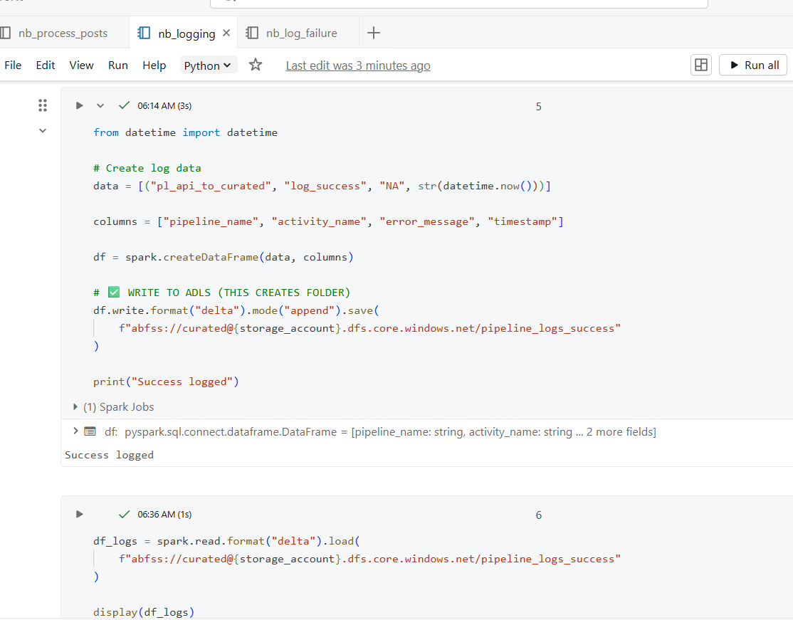
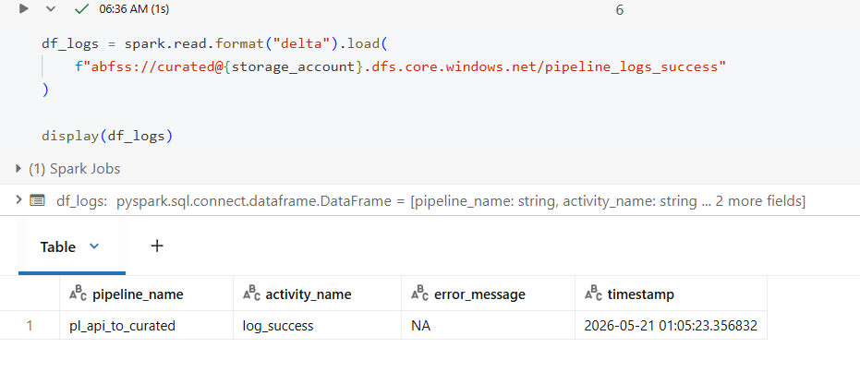

🧪 Testing Strategy

✅ Test Case 1: Success Scenario
Steps:
- Run pipeline normally
Expected Result:
- All activities succeed
- Data written to curated layer
- Success log created

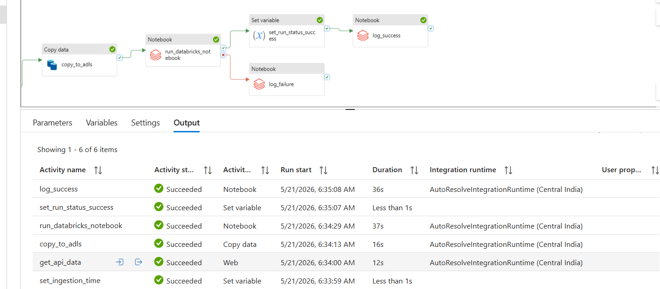
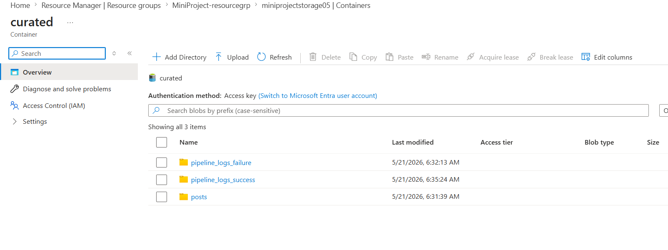
❌ Test Case 2: Failure Scenario
Steps:
- Introduce error in notebook:
Expected Result:
- Pipeline fails
- log_failure triggered
- Error captured in ADLS
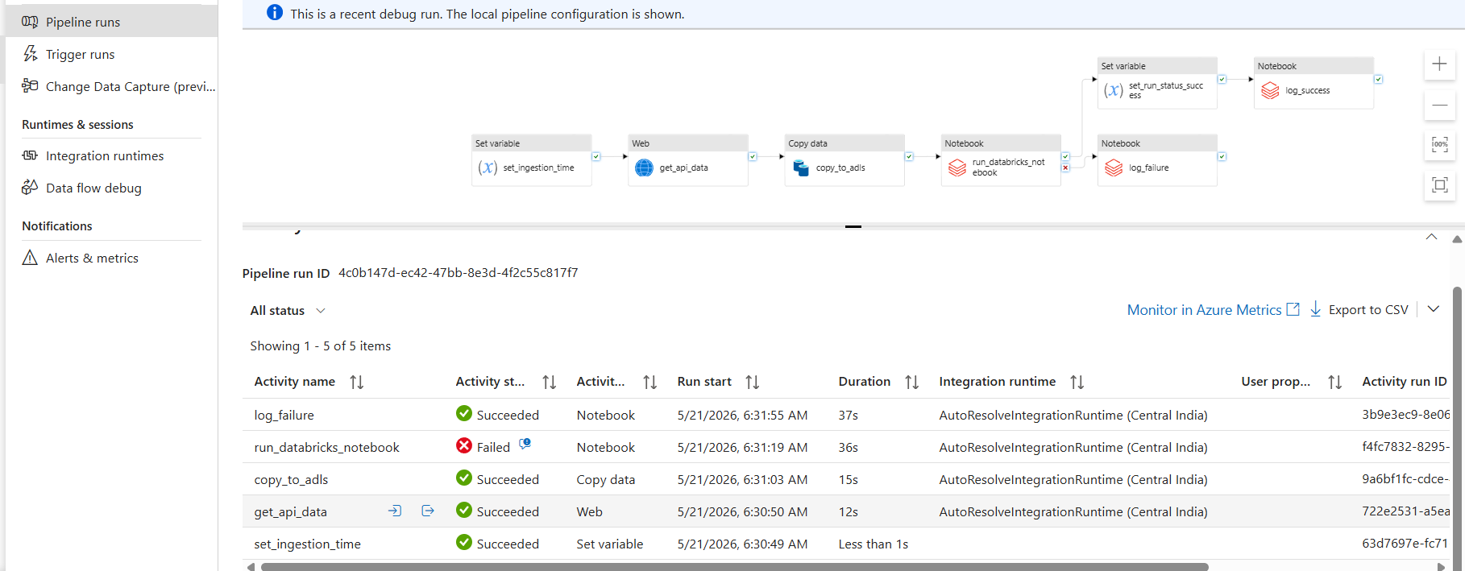


🚀 Key Learnings
- ADF orchestration concepts
- Databricks notebook integration
- ADLS access via Service Principal
- Delta Lake storage
- Error handling in pipelines
- Logging framework design

🏁 Conclusion
Successfully built a complete data pipeline with:
- End-to-end orchestration
- Data transformation
- Secure ADLS integration
- Robust logging system
………………………………………………………………….…………………………………………………………………………………………………………………………………………………………………………………………………………………………….

